Installation of the Wrist Temperature Measurement Module of Face Recognition and Temperature Measurement Terminal
(Outside China)

Document Version: V1.0
Revision Record
Date | Version | CR ID/Defect ID | Section No. | Description | Revised By
2020-04-21 | 1.0 |  |  | Released the first version. | LW8328

Thank you for purchasing our product. If you have any questions or need assistance, please contact the dealer.
Disclaimer
No part of this manual may be copied, reproduced, translated, or distributed in any form or by any means without prior written consent from Uniview.
The manual may be updated from time to time due to version upgrade or other reasons.
The manual is for reference only. All the statements, information, and suggestions contained herein do not constitute warranties of any kind, express or implied.
Conventions
- The figures, charts or photos in this manual are used for illustration only, which may differ from the actual product.
- Subject to uncertain factors such as the physical environment, actual values of some data may differ from the reference values described herein. In case of any doubt or dispute, the right of final interpretation resides with Uniview.
- Follow this manual when using the product. Professional guidance is recommended.
- Notational conventions used in this document are described as follows:
Format | Description
Boldface | Indicates buttons, menus, tabs, window names, dialog names, and parameter names. For example, click OK or select Device Management.
" " | Indicates messages. For example, "Hanging Up" is displayed on the interface.
> | Directs you to go to a multi-level menu. For example, go to Device Management > Add Device. In this example, Add Device is a submenu under Device Management.

- The symbols in the following table may be found in this manual. Carefully follow the instructions indicated by the symbols to avoid hazardous situations and use the product properly.
Symbol | Description
WARNING! | Contains important safety instructions and indicates situations that could cause bodily injury.
CAUTION! | Means reader be careful and improper operations may cause damage or malfunction to product.
NOTE! | Means useful or supplemental information about the use of product.

Contents
Foreword 3
1 Overview 3
1.1 Features 3
2 Engineering Safety Precautions 4
3 Installation Preparations 5
3.1 Installation Tools 5
4 Overview of Wrist Temperature Measurement Module 7
4.1 Appearance and Size 7
4.2 Structure and Cable 7
4.3 Accompanying Accessories 8
4.4 Engineering Wiring 8
4.5 Brackets 9
4.5.1 Wall-mounted Bracket 9
4.5.2 Side-mounted Bracket 10
5 Installation of the Wrist Temperature Measurement Module of Face Recognition Access Control Terminal 11
5.1 Installation Precautions 11
5.2 Standing Pole Mount 11
5.3 Wall Mount 12
6 Installation of the Wrist Temperature Measurement Module of Face Recognition Terminal 15
6.1 Standing Pole Mount 15
6.2 Installation to a Gate Machine 16
7 Parameter Configuration 18
7.1 Parameter Configuration on Web 18
7.1.1 Device Startup and Login 18
7.1.2 Enabling Temperature Measurement 19
7.1.3 Enabling Mask Detection 20
7.1.4 Configuring a Check Template 21
7.2 Parameter Configuration on the GUI Touchscreen 21
8 Appendix 23
8.1 Labels 23
8.2 Standing Pole Bracket Slide 24
8.2.1 Dimensions of a Standing Pole Bracket Slide 24
8.2.2 Installation Positions of a Standing Pole Bracket Slide 25
8.2.3 Installation of the Standing Pole Bracket Slide for Face Recognition Access Control Terminal 26
8.2.4 Installation of the Expansion Bracket for Face Recognition Terminal 27
8.3 Standing Pole Bracket Base 28
8.3.1 Dimensions of a Standing Pole Bracket Base 28
8.3.2 Installation of the Standing Pole Bracket Base 29

Foreword
This document describes the installation of wrist temperature measurement modules. It is intended for Uniview personnel responsible for installing and debugging face recognition terminals as well as implementation and maintenance personnel of integrators and contractors. The personnel above are strongly recommended to read through this document before commencing the engineering design, device wiring, and installation.

Overview
A wrist temperature measurement module is a non-contact device for taking wrist temperatures. It has a simple and elegant appearance and features a wide range, high precision, low error, and long temperature measurement distance. It can connect to a face recognition terminal through the RS485 interface. The module supports temperature measurement and personnel information binding. It is capable of rapidly identifying personnel information, taking the temperature, and generating an alarm for people with abnormal temperature. In addition, it allows setting a temperature threshold so as to strictly control the access permissions of personnel (a person is not allowed to pass when the person's temperature exceeds the threshold). The module is applicable to application scenes requiring strict temperature measurement such as access control and attendance check.
This document provides introduction to wrist temperature measurement modules and guidance on the wiring.

Features
- Liveness detection, mask detection, and temperature measurement
- Face metering, human metering, and intelligent metering, as well as quick adaptation to ambient light, effectively improving the recognition efficiency under strong backlight
- Accurate face recognition of people in the whitelist with masks
- Plug-and-play, standalone running with network disconnected, simple and rapid deployment, allowing temporary and mobile deployment
- User-friendly interaction, real-time temperature display on the GUI, real-time voice prompt, and voice alarms for abnormal temperatures, enabling inspectors to rapidly respond
- Non-contact recognition, avoiding contact infection
- Binding of personnel information, face photos, and body temperatures, quickly identifying personnel and temperatures, and enabling record storage and export
- Built-in chip dedicated for deep learning, allowing local and offline recognition
- Multiple authentication modes available: face scan, ID card verification, ID card verification + ID card whitelist, card swiping (IC card reader connected), as well as card swiping (IC card reader connected) + face scan

Engineering Safety Precautions
- Construction personnel need to wear antistatic wrist straps or gloves as required before carrying out construction work.
- Do not work on an electrified device to ensure safe electricity use.
- Prevent exposed wire ends during construction. Strictly insulate and wrap the wiring sections.
- During on-site installation, avoid poor cable contact caused by long-term stress, and do not excessively bend tail cables (including power cables and network interface cables).
- The device must be placed or installed stably and reliably and cannot fall.
- The device must be correctly installed before it can be powered on and used. Incorrect connection may cause personal injury and damage to the device components.
- The device must be disconnected from the power supply before it can be moved to prevent electric shock.
- The device must be away from water and other liquids to prevent damage to the device and risks of electric shock, fire, etc.
- Use a power outlet with a protective earth connection.
- For a device with grounding requirements, ground it in accordance with the regulations.
- Strictly comply with local electrical safety standards.
- The voltage must be stable and within the rated input and output range, and meet the power supply requirements of the device. The overall power must be greater than the sum of the designed maximum power of the device.
- The device must be placed or installed in a place with the temperature, humidity, dust, corrosive gas, electromagnetic radiation and other indicators meeting the requirements of the device.

Installation Preparations

Installation Tools
The table below lists the tools required in the installation.
            - Installation Tools
Tool | Picture
Hex key | 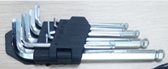  Used to loosen or fasten hex socket screws.
Precision maintenance electronic kit | 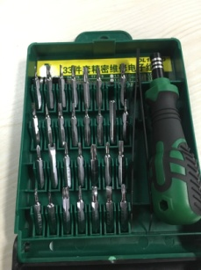  With 33 or more parts for wiring.
Antistatic wrist strap or antistatic gloves | 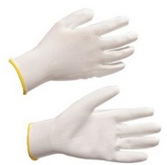
Marker | There is no special requirement.
Measuring tape | 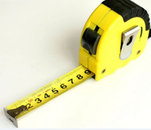  Used to measure dimensions.
Glue gun and silicone sealant | 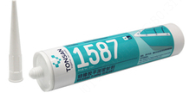  Used for water prevention at the bottom of face recognition terminals. TONSAN 1587 is recommended.
Drill  3–10mm drill bit kit | 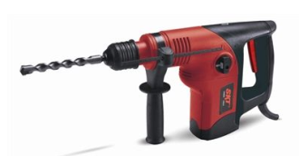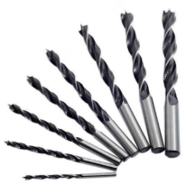  Used to drill holes.  Note: The drill bits must be able to drill on stainless steel.
Multimeter | 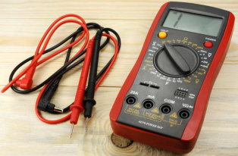  Used for measuring the voltage and current.
Power adapter (DC 12V 2A) | 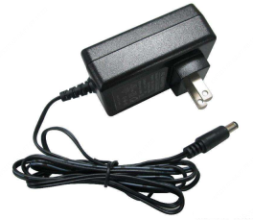  Used to connect to the power supply and power the module.
Network cables | Cat 5e or better cables need to be used.

Overview of Wrist Temperature Measurement Module

Appearance and Size
- Appearance and Size of OEP-BTS1

Structure and Cable
- Structure and Cable
Temperature sensor
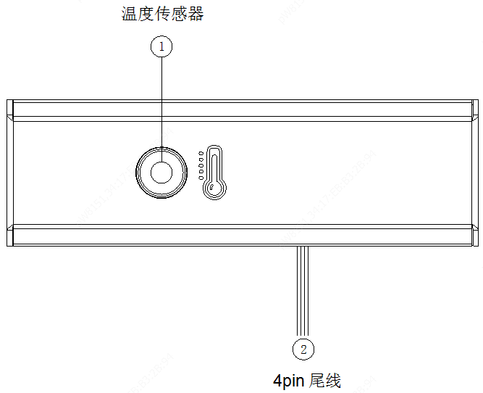
4-pin cable

Accompanying Accessories
Item | Name | Quantity | Unit
1 | Digital temperature measurement module | 1 | PCS
2 | Screw kit  (including two M3x6 countersunk head screws, and two M3x6 pan head screws, BOM 2603C01J) | 1 | Bag
3 | Power adapter (purchased separately) | 1 | PCS
4 | Side-mounted bracket | 1 | PCS
5 | Hint label | 3 | PCS
6 | User manual | 1 | Set

Engineering Wiring
- Wiring Schematic Diagram

Temperature measurement module
VDD12V red
GND black

Power input

Face recognition access control terminal/Face recognition terminal
RS485_P blue
RS485_N brown
RS485

Note: Before installing the digital temperature measurement module, plan the layout of the power cable. For the diameter selection for the extension power cable, see the table below.
            - Diameter Selection for Extension Power Cables
The device is powered by DC 12V/2A and the lower limit of the operating voltage is DC 9V (12V–25%).
Wire Diameter (mm) | 0.8mm  (20 AWG) | 1mm  (18 AWG) | 1.25mm  (16 AWG) | 1.63mm  (14 AWG)
Transmission Distance (m) | 18 | 37 | 58 | 99

 | CAUTION! | Cable connection requirements:  - The 4-pin cable needs to be adjusted properly based on the actual scenario.  - Cables need to pass the continuity check before they are laid out.  - Cables need to be routed naturally and straight, without cross-winding or knotting, and the traction should be balanced.  - Cable connection points and terminals should be numbered uniformly and marked permanently, and labels should be set at both ends of a cable.  - The bending radius of a multi-core cable should be greater than 6 times its outer diameter, and the bending radius of a 4-pair network data cable should be greater than 4 times its outer diameter.

Brackets

Wall-mounted Bracket
- Wall-mounted Bracket of a Wrist Temperature Measurement Module
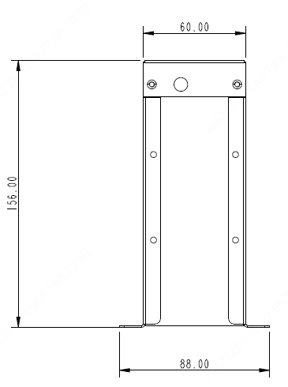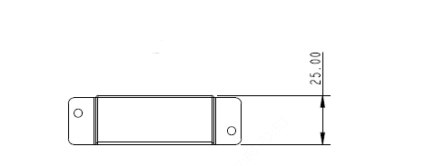

Side-mounted Bracket
- Side-mounted Bracket of a Wrist Temperature Measurement Module
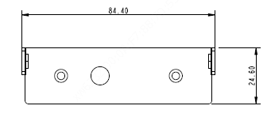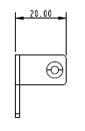
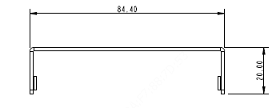
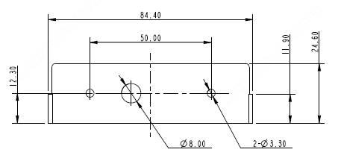

Installation of the Wrist Temperature Measurement Module of Face Recognition Access Control Terminal

Installation Precautions
- Before installation, check the power and communication conditions at the site to avoid pipes inside or on the wall during construction.
- For wall mount, measure the dimensions of the installation wall to check whether there is space for installation, and check the wall material and wall repair before grooving.
- Arrange tail cables in order during installation to avoid bending, winding, and crushing damage. Wrap tail cables of the temperature measurement module with insulation tape to prevent damage during the installation.
- Do not install the temperature measurement module with the temperature measurement hole facing upward, and protect the hole from foreign matters, dust, and other contamination.
- A temperature measurement module is a precision device. Be sure to handle it gently during transportation, and never install it forcibly to avoid incidental damage.

Standing Pole Mount
- Determine the standing pole mount holes.  The standing pole provides two installation positions (at heights of 900mm and 1093mm, respectively) for a wrist temperature measurement module. Select the position based on actual situation.  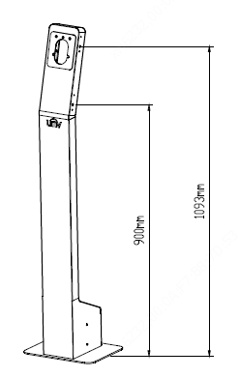 | - Install the wrist temperature measurement module bracket to the standing pole.  - Fix to the 900mm position.  Screws: two M3x6 countersunk head screws  Operation: Use two countersunk head screws to fix the wrist temperature measurement module bracket to the right side of the standing pole. You can select the installation position based on the on-site situation.  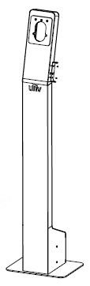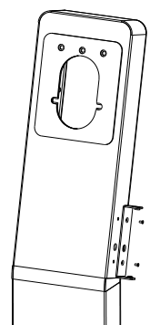

- Install the wrist temperature measurement module bracket to the standing pole.  - Fix to the 1093mm position.  Screws: two M3x6 pan head screws  Operation: Use the screws to fix the wrist temperature measurement module bracket to the right side of the standing pole. You can select the installation position based on the on-site situation.  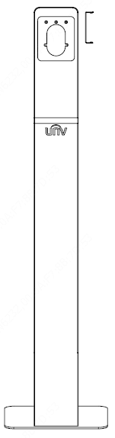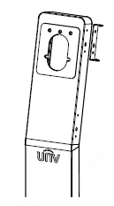 | - Fix the wrist temperature measurement module.  Screws: two M3x6 pan head screws  Operation: Use two pan head screws to fix the wrist temperature measurement module to the bracket at the right side of the standing pole.  Installation Completed  Fixing the Wrist Temperature Measurement Module  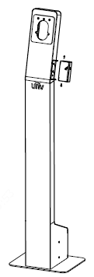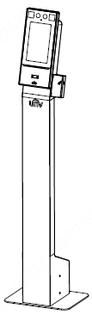

Wall Mount
Note: The wall-mounted bracket for EP-SZWB needs to be purchased separately, and the BOM code is 2115C0EV.

Solution 1 (temperature measurement hole facing downward)
- Fix the wrist temperature measurement module.  Screws: two M3x6 pan head screws and two M3x6 countersunk head screws  Operation: Use the countersunk head screws to fix the wall-mounted bracket and side-mounted bracket, and then use the pan head screws to fix the device to the side-mounted bracket.  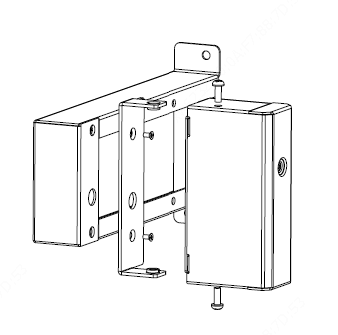 | - Install the wall-mounted bracket.  Screws: two ST3.5x25 countersunk head self-tapping screws  Operation: Use the self-tapping screws to fix the wall-mounted bracket to the proper position on the wall determined as required.  Mode 1: Mode 2:  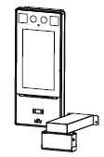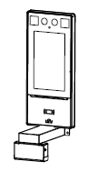

Solution 2 (temperature measurement hole facing rightward)
- Fix the wrist temperature measurement module.  Screws: two M3x6 pan head screws and two M3x6 countersunk head screws  Operation: Use the countersunk head screws to fix the wall-mounted bracket and side-mounted bracket, and then use the pan head screws to fix the device to the side-mounted bracket. | - Install the wall-mounted bracket.  Screws: two ST3.5x25 countersunk head self-tapping screws  Operation: Use the self-tapping screws to fix the wall-mounted bracket to the proper position on the wall determined as required.  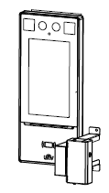

Solution 3 (temperature measurement hole facing forward)
- Fix the wrist temperature measurement module.  Screws: two M3x6 pan head screws and two M3x6 countersunk head screws  Operation: Use the countersunk head screws to fix the wall-mounted bracket and side-mounted bracket, and then use the pan head screws to fix the device to the side-mounted bracket.  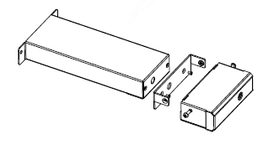 | - Install the wall-mounted bracket.  Screws: two ST3.5x25 countersunk head self-tapping screws  Operation: Use the self-tapping screws to fix the bracket to the proper position on the wall determined as required.  Mode 1: Mode 2:  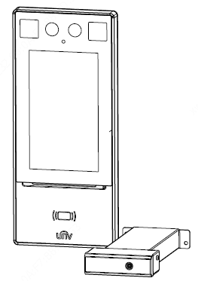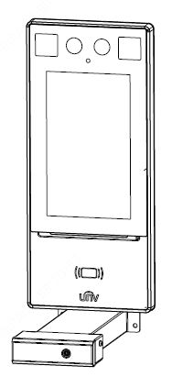

Solution 4 (temperature measurement hole facing forward without the wall-mounted bracket)
- Install the side-mounted bracket.  Screws: two ST3.5x25 countersunk head self-tapping screws  Operation: Use the self-tapping screws to fix the side-mounted bracket to the proper position on the wall determined as required: Determine the installation holes as shown in the figure below, and fasten two countersunk head self-tapping screws to install the bracket.  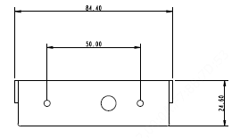 | - Fix the wrist temperature measurement module.  Screws: two M3x6 pan head screws  Operation: Insert the wrist temperature measurement module to the bracket, and use the pan head screws to fasten it at both sides.  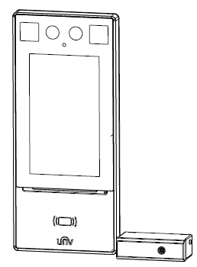

Installation of the Wrist Temperature Measurement Module of Face Recognition Terminal
Note: When a gate machine is used in combination, it must be connected to a face recognition terminal and support RS485 signal transmission so that it can normally interact with the wrist temperature measurement module.

Standing Pole Mount
- Determine the standing pole mount holes.  The standing pole provides two installation positions (at heights of 900mm and 1093mm, respectively) for a wrist temperature measurement module. Select the position based on actual situation. | - Install the wrist temperature measurement module bracket to the standing pole.  - Fix to the 900mm position.  Screws: two M3x6 countersunk head screws  Operation: Use two countersunk head screws to fix the wrist temperature measurement module bracket to the right side of the standing pole. You can select the installation position based on the on-site situation.

- Install the wrist temperature measurement module bracket to the standing pole.  - Fix to the 1093mm position.  Screws: two M3x6 pan head screws  Operation: Use the screws to fix the wrist temperature measurement module bracket to the right side of the standing pole. You can select the installation position based on the on-site situation.  Fixing the Wrist Temperature Measurement Module | - Fix the wrist temperature measurement module.  Screws: two M3x6 pan head screws  Operation: Use two pan head screws to fix the wrist temperature measurement module to the bracket at the right side of the standing pole.  Installation Completed  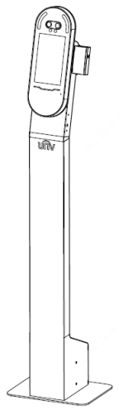

Installation to a Gate Machine

Solution 1 (fixing by pasting)
Recommended: Use 3M double-sided tape to paste and fix the wrist temperature measurement module to the upper cover, and use insulation tape to wrap the tail cable and connect the cable to the chassis.

                - Fix the wrist temperature measurement module.
Tool: 3M double-sided tape or other adhesive for fixing
Operation: Directly fix the wrist temperature measurement module to the upper cover.
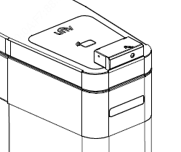

Solution 2 (fixing on holes)
Drill two φ3.3 holes and one φ8 hole at the side of the upper cover of the gate machine, fix the side-mounted bracket, and then install the wrist temperature measurement module.
- Drill holes on the gate machine and fix the wrist temperature measurement module bracket.  Screws: two M3x6 countersunk head screws  Operation: At the side of the upper cover of the gate machine, drill two φ3.3 holes and one φ8 hole according to the dimensions shown in Figure 4-5, and use the countersunk head screws and caps to fix the wrist temperature measurement module bracket. | - Fix the wrist temperature measurement module to the bracket.  Screws: two M3x6 pan head screws  Operation: Insert the wrist temperature measurement module to the side-mounted bracket, and use one pan head screw to fasten it at each side.  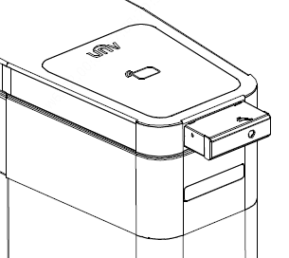

Solution 3 (fixing to a wall)
If there is a wall or any other surface that can be used to fix the wrist temperature measurement module next to the gate machine, install the module to the fixing surface, and cut a groove on the surface for conceal cabling or use a cable trough.
- Fix the wrist temperature measurement module bracket.  Screws: two ST3.5x25 countersunk head self-tapping screws  Operation: Drill two φ3.3 holes on the installation surface according to the dimensions shown in Figure 4-5, and use expansion screw to install the wrist temperature measurement module bracket. | - Fix the wrist temperature measurement module to the bracket.  Screws: two M3x6 pan head screws  Operation: Insert the wrist temperature measurement module to the side-mounted bracket, and use one pan head screw to fasten it at each side.  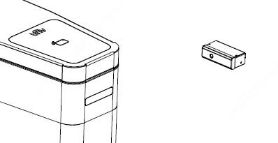

Parameter Configuration

Parameter Configuration on Web

Device Startup and Login
After the device is installed, connect it to a DC 12V power supply and start the device. The device screen will light up, indicating that the device is started successfully. (For a device in the access control terminal series, the activation password needs to be configured for initial activation.) Log in to the Web interface of the device via network connection, to manage and maintain the device.
              - On a client PC, open the Internet Explorer, and enter the IP address of the device 192.168.1.13 (subnet mask: 255.255.255.0) into the address bar.
              - In the login dialog box, enter the username (admin by default) and password (123456 by default, or the activation password if configured), and click Login to access the Web interface.

 | NOTE! | - Internet Explorer needs to be used.  - DHCP is enabled by default. If a DHCP server is used in the network environment, an IP address may be dynamically assigned to the device. Log in with the actual IP address.  - At initial login, the system will prompt you to install a plugin. Close all browsers when installing the plugin. Follow instructions on the page to complete the plugin installation, and then restart the Internet Explorer to log in to the system.  - The default password of this product is used only for initial login. You are required to change the default password after initial login to ensure security. It is strongly recommended that the password be set to a stronger one with no less than eight characters.

Enabling Temperature Measurement
Log in to the Web interface of the device, choose Setup > Intelligent > Advanced Setting, select Temperature Measurement, and set Temperature Measurement, Temperature Measurement Range, and Temperature Alarm Threshold as required.
- Enabling Temperature Measurement
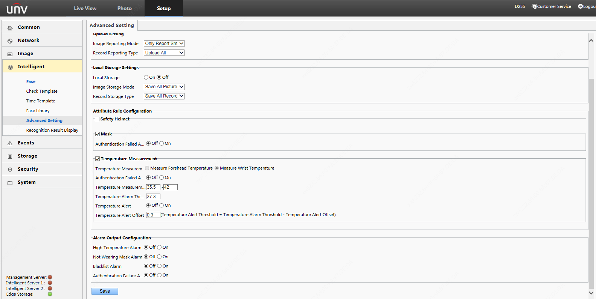

Enabling Mask Detection
Log in to the Web interface of the device, choose Setup > Intelligent > Advanced Setting, and select Mask in the Attribute Rule Configuration pane.
- Enabling Mask Detection
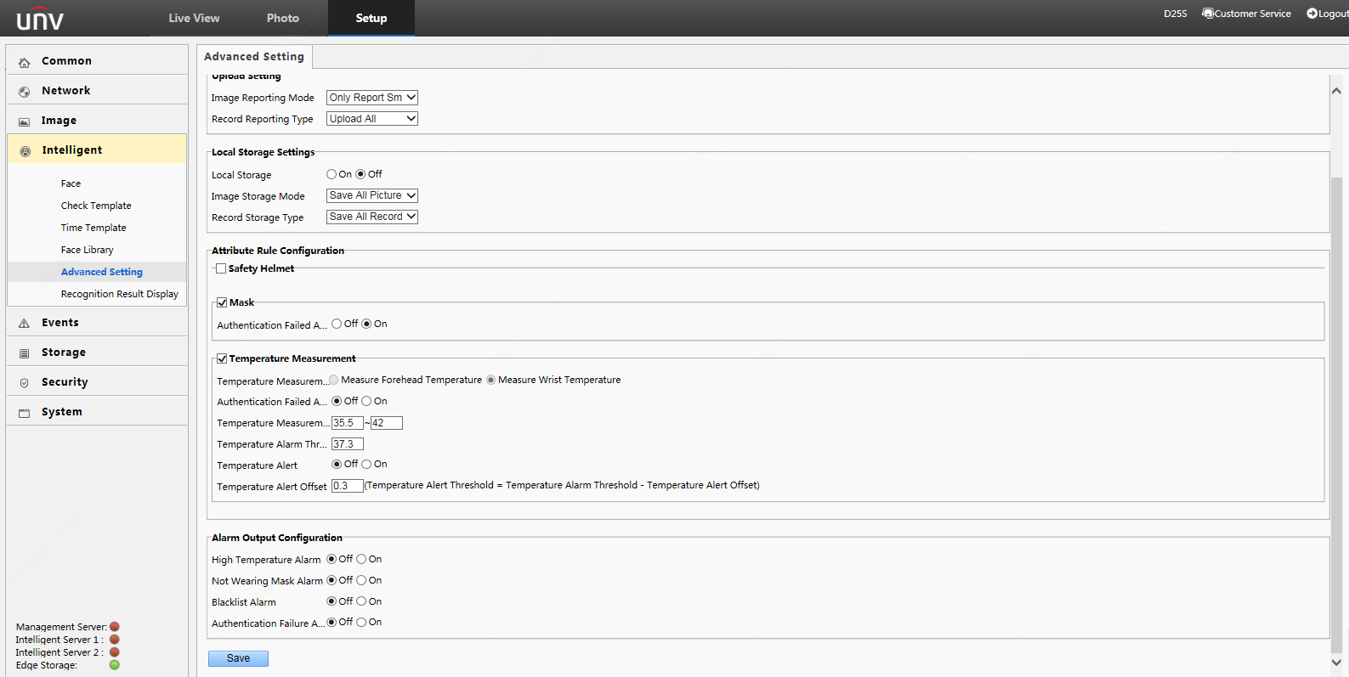

Configuring a Check Template
You can configure a check temperature to combinations such as face + mask + temperature, or ID card + mask + temperature.
When you set a check template to None, Temperature Measurement Only mode is adopted.
- Configuring a Check Template
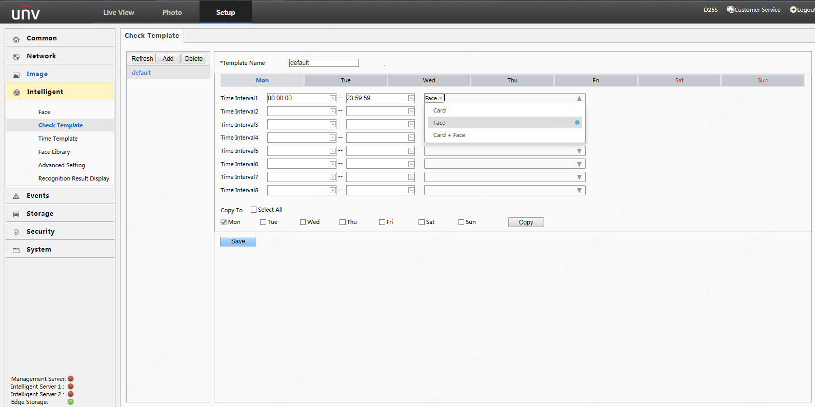

Parameter Configuration on the GUI Touchscreen
Tap and hold the touchscreen, enter the password to go to the activation config interface, select Authentication scene, and choose a temperature measurement mode.
Note: Some models do not support parameter configuration on the GUI.
- Configuring on the GUI
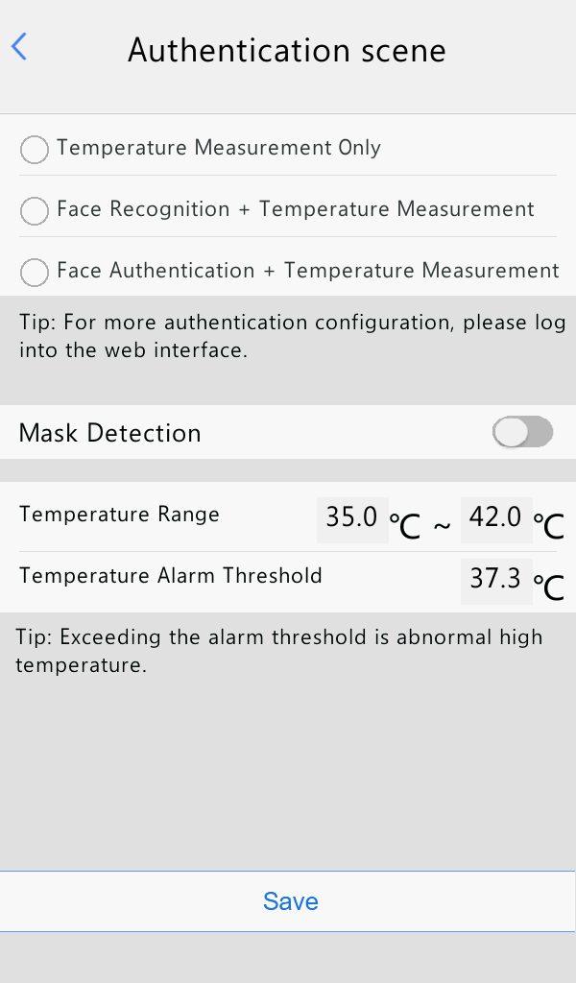
- Temperature value range: 35°C to 40°C
- Mask Detection
- Temperature Measurement Only: pure temperature measurement mode
- Face Recognition + Temperature Measurement: face scan + temperature measurement mode
- Face Authentication + Temperature Measurement: face whitelist + temperature measurement mode

Appendix

Labels
The packing list contains temperature measurement hint labels, which directly tell users the temperature measurement point and distance. After installing the device, attach the label to a proper position of the temperature measurement module.
Figure ‎8-1 Labels
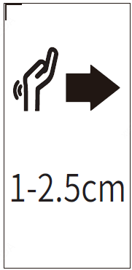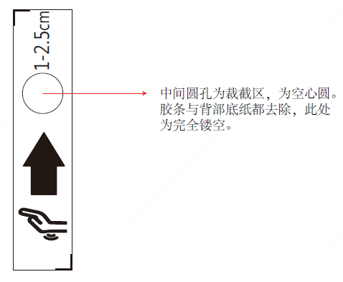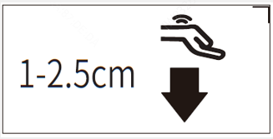
The round hole is cut to be hollow. Both the adhesive tape and the backing paper are completely removed in the circle.
(1) (2) (3)
No. | Label Attaching Description
1 | This label is applicable when the temperature measurement module is installed on a wall or standing pole. For details, see solution 2 in section "Wall Mount" and section "Standing Pole Mount".
2 | This label is applicable when the temperature measurement module is mounted on a wall and the temperature measurement point is outward. For details, see solutions 3 and 4 in section "Wall Mount".  NOTE!  As shown in the figure above, the round film on the label aimed at the temperature measurement point must be removed when the label is attached.
3 | This label is applicable when the temperature measurement module is mounted on a wall and the temperature measurement point is downward. For details, see solution 1 in section "Wall Mount".

Standing Pole Bracket Slide
A standing pole bracket slide is optional, and the BOM code is 2115C0F3.

Dimensions of a Standing Pole Bracket Slide
Figure ‎8-2 Dimensions of an Expansion Bracket
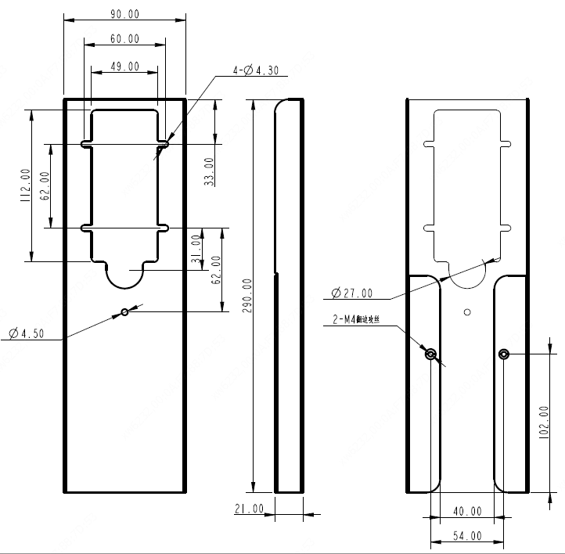
2-M4 extruded and tapped

Installation Positions of a Standing Pole Bracket Slide
Note:
- Heights in the table are distances from the bottom of the pole to the top of the device, in the unit of meter.
- For a 10-inch face recognition access control terminal, only positions +2 and +3 of the standing pole bracket slide are applicable.
            - Face Recognition Access Control Terminal
Installation Position | +3  (+0.21m) | +2  (+0.15m) | +1  (+0.09m) | 0  (Original position) | –1  (–0.02m) | –2  (–0.08m) | –3  (–0.14m)
7-inch face recognition access control terminal | 1.418m | 1.358m | 1.298m | 1.203m | 1.179m | 1.119m | 1.059m
10-inch face recognition access control terminal | 1.431m | 1.371m | / | 1.216m | / | / | /
            - Face Recognition Terminal
Installation Position | +3  (+0.15m) | +2  (+0.09m) | +1  (+0.03m) | 0  (Original position) | –1  (–0.03m) | –2  (–0.09m) | –3  (–0.15m)
Face recognition terminal | 1.423m | 1.363m | 1.303m | 1.268m | 1.243m | 1.183m | 1.123m

Installation of the Standing Pole Bracket Slide for Face Recognition Access Control Terminal
The installation of the standing pole bracket slide for a 7-inch face recognition access control terminal is the same as that for a 10-inch face recognition access control terminal. This section describes the installation of the standing pole bracket slide for a 7-inch face recognition access control terminal.
Note: Operations in this section raise the height of the device. To lower the device, rotate the standing pole bracket slide by 180°, and perform the operations as the same.
- Fix the wall-mounted bracket.  Screws: two M4x14 grub Phillips screws and two style-1 M4 hexagon nuts  Operation: Use two grub screws and M4 nuts to fix the wall-mounted bracket of the access control terminal to the expansion bracket.  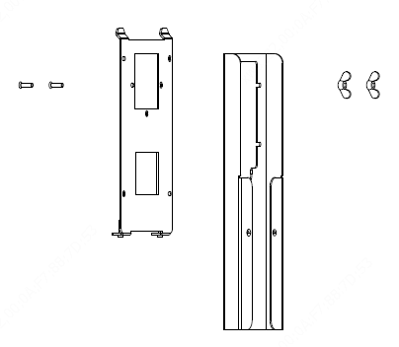 | - Fix the expansion bracket.  Screws: two hex tamper screws supplied with the wall-mounted bracket  Operation: Install the device to the combination bracket assembled in step 1, and tighten the two tamper screws at the bottom.  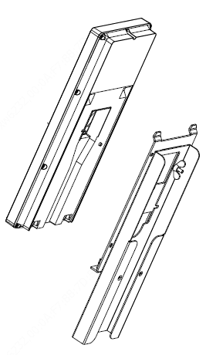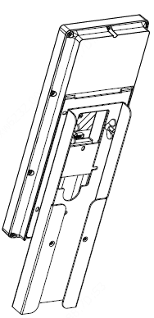
- Fix the standing pole.  Screws: two M4x8 Phillips pan head screws  Operation: Use two M4 Phillips pan head screws to fix the combination assembled in step 2 to the standing pole.  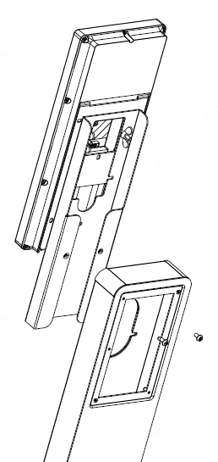 | - Complete the installation.  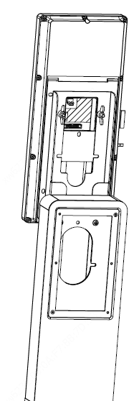

Installation of the Expansion Bracket for Face Recognition Terminal
Note: Operations in this section raise the height of the device. To lower the device, rotate the expansion bracket by 180°, and perform the operations as the same.
- Fix the device.  Screws: two M4x8 pan head screws  Operation: Pass the tail cables of the face recognition terminal through the expansion bracket, and use M4x8 pan head screws to install the terminal to the expansion bracket.  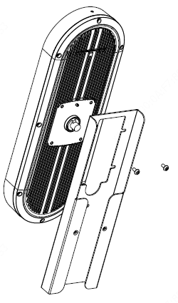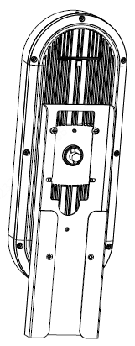 | - Fix the standing pole.  Screws: two M4x8 pan head screws  Operation: Install the combination assembled in step 1 to the standing pole.  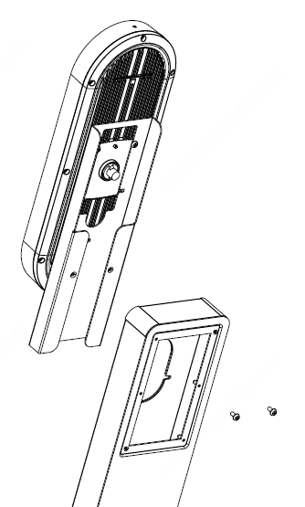
                - Complete the installation.
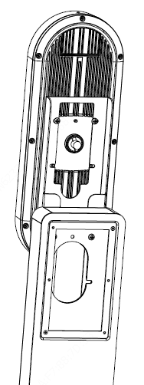

Standing Pole Bracket Base
A standing pole bracket base is optional, and the BOM code is 2115C0F4.

Dimensions of a Standing Pole Bracket Base
Figure ‎8-3 Dimensions of a Standing Pole Bracket Base
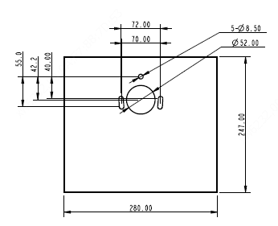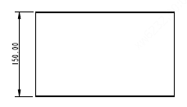

Figure ‎8-4 Base Mount Holes
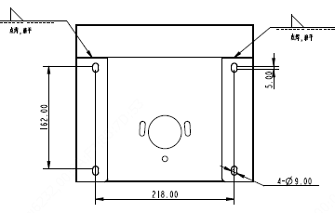
Spot welding and planishing
Spot welding and planishing

Installation of the Standing Pole Bracket Base
- Disassemble the cover at the bottom of the standing pole.  Operation: Use a Phillips screwdriver to disassemble the cover at the bottom of the standing pole.  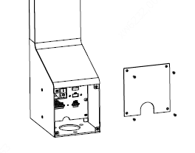 | - Install the base.  Screws: three M8x15 hex socket screws  Operation: Use hex screws and caps to fix the standing pole to the base, and assemble the cover back to the bottom of the standing pole.  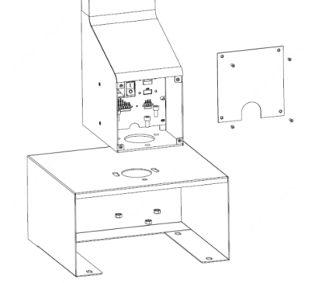
                - Complete the installation.
Screws: four M8x80 expansion bolts
Operation: Fasten the expansion bolts and install the cover.
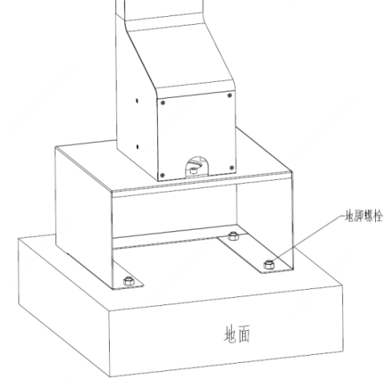
Anchor bolt
Ground

