Precautions for Using the Wrist Temperature Measurement Module of Face Recognition and Temperature Measurement Terminal
(Outside China)

Document Version: V1.0

Revision History
Date | Version | Description | Revised By
2020-04-20 | 1.0 | Released the first version. | LW8328

Precautions
- OEP-BTS1 needs to work in an indoor windless environment with the temperature between 15°C and 30°C. OEP-BTS1-BD needs to work in an indoor windless environment with the temperature between 10°C and 40°C. The effect of outdoor use cannot be guaranteed. The device is not waterproof. If the device is used outdoors, a sealed and well-insulated environment using heat-insulation materials and no window, such as a tent or makeshift, needs to be built, and an L-shaped walkway needs to be set.
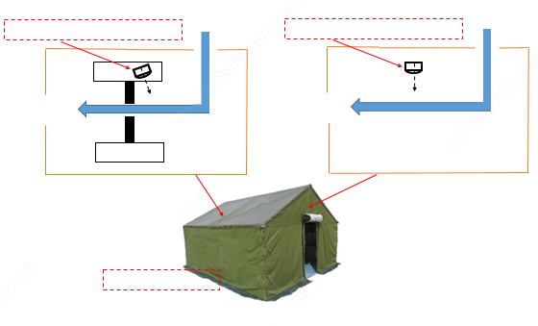
Heat-insulation material required
Temperature measurement device
Temperature measurement device on a standing pole
Personnel movement direction
Adjust the angle properly to avoid the entrance direction.

Personnel movement direction
Adjust the angle properly to avoid the entrance direction.
Tent/Makeshift
Gate
Method 2
Method 1
Gate
- Within 1 meter in front of the temperature measurement hole, do not set walkways. Passers-by or other moving heat sources may cause incorrect measurement results. Ambient temperature close to human body temperature may cause slow measurement or measurement failure. The installation position should be properly selected.
- For OEP-BTS1, the recommended distance between the wrist and the temperature measurement point is 1–2.5cm. For OEP-BTS1-BD, the recommended distance is 1–4cm. Wrists too close to or too far from the temperature measurement module will affect the measurement results.
- The temperature measurement hole is in the upper part of the temperature measurement module. Be sure to aim the wrist at the temperature measurement hole. Otherwise, the measured temperature may be lower than the actual temperature.
- If the device prompts "low temperature", check whether the wrist aims at the temperature measurement hole, or measure the wrist part covered by clothes again.
- When the ambient temperature is low, and if you have the temperature taken immediately after rolling up the sleeve, the measured temperature may be slightly higher. You can have the temperature taken a moment later.
- The device is used only to preliminarily detect people with abnormal temperatures. If several measurement results of a person are abnormal (the device prompts "low temperature" or "abnormal temperature") after the above treatment, use a medical-grade temperature measurement device for a recheck.

